**TASK 1(A)**

**Objective:** Write a recursive function that prints alphabets from A to J.

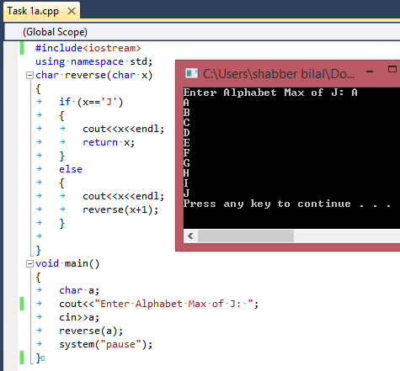

**TASK 1(B)**

**Objective:** Write a recursive function that prints alphabets from A to J in reverse order.

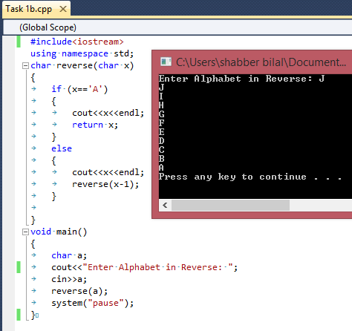

**TASK 2**

**Objective:** Write a recursive function that computes the factorial of number given by user.

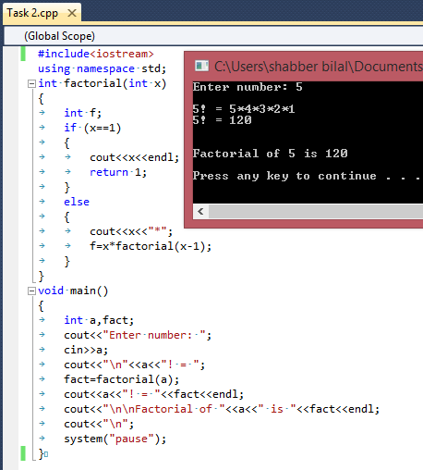

**TASK 3**

**Objective:**

Write a recursive function prints the fabonic series.You have to print series uptill number entered by user.

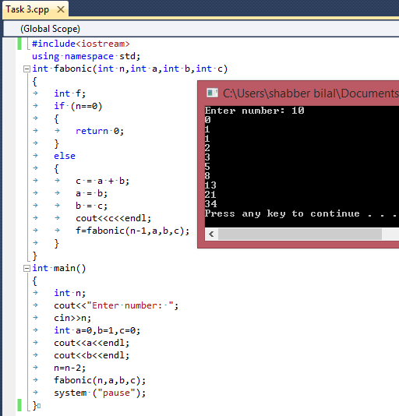

**TASK 4**

**Objective:**

Write overeloaded function that computes the average of 10 integers and average of 10 float numbers.

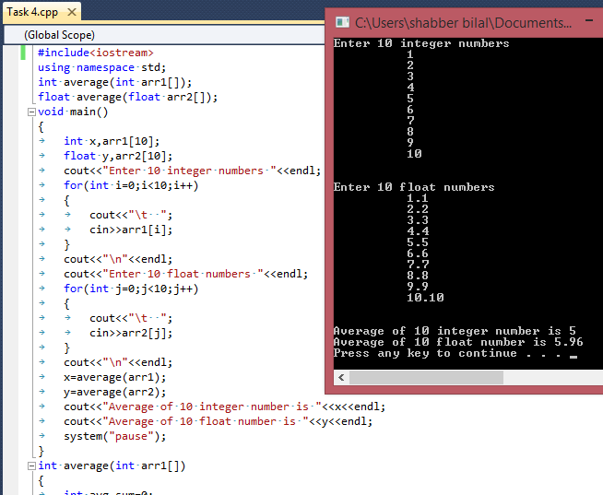

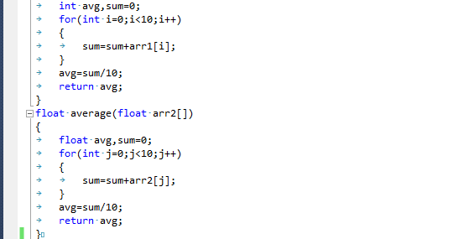

**TASK 5**

**Objective:**

Write overeloaded functions **Area**that calculate the area of circle ,rectangle and triangle.

Area of circle = 3.14*r*r & Area of rectangle = width*height & Area of triangle = ½ height*base

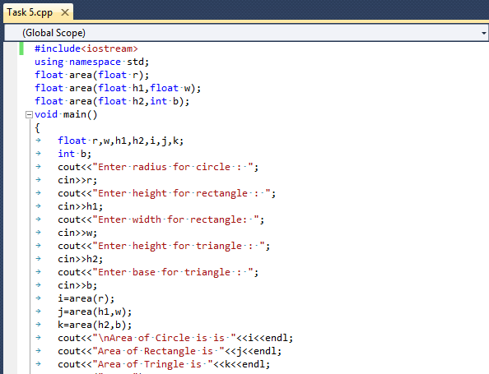

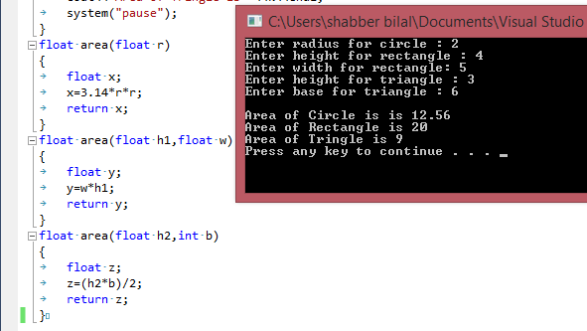

**TASK 6**

**Objective:**

Write overeloaded function that computes the Percentage of three courses and percentage of five courses.

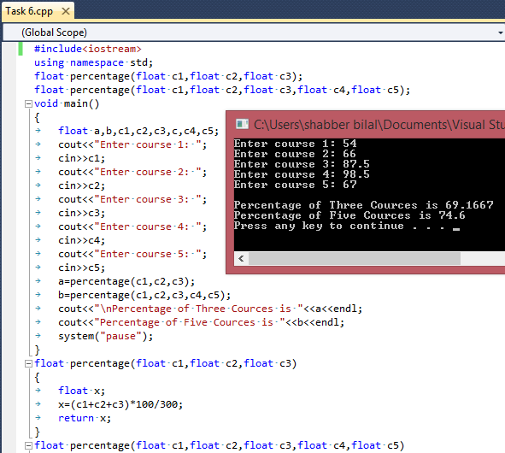

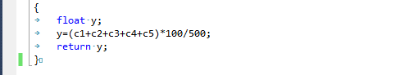

**TASK 7**

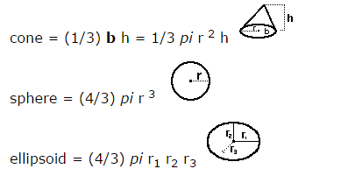**Objective:**

Write overeloaded function **Volume** that alculates the volume of cone, sphere and ellipsoid.Formulae are given below.

